**Check-In Process**

**This is doc is designed for you to update to make your own**

**[PLEASE ADD INSTRUCTIONS HERE FOR YOUR VOLUNTEERS TO GAIN ADMIN ACCESS TO YOUR EVENT PAGE - BELOW IS JUST AN EXAMPLE]**

[INSERT YOUR OWN ORGANIZATION EVENT QR CODE - DELETE THE ONE BELOW]



Email: [INSERT EMAIL ADDRESS YOU WANT VOLUNTEERS TO USE TO LOGIN]

PW: [INSERT PASSWORD FOR THE ABOVE LOGIN]

1. Go to the [INSERT NAME OF YOUR TICKETING] Tab
2. Click “Manage Events on this Tab”
3. Click “Reservations / Slots” on the far right

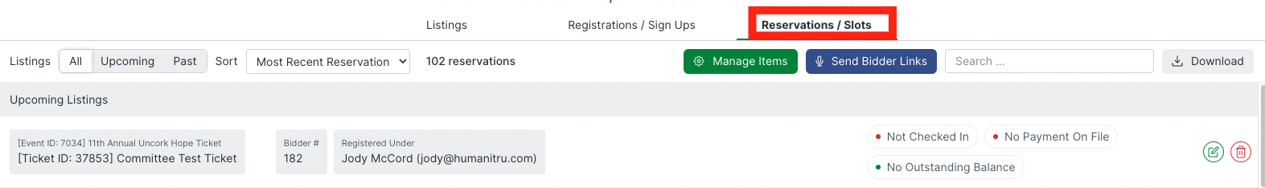

1. Make sure “Listings” is set to “All”

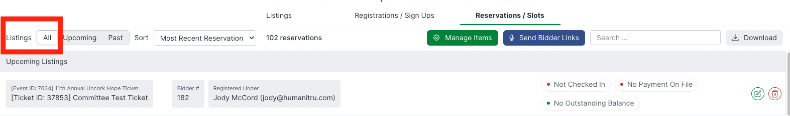

1. **Search for guests using the “Reservations” search bar**
   1. You can use the search bar to search for a person's name, bidder number, or the person/company who purchased a ticket on their behalf.
   2. If you cannot find their name, ask who purchased the ticket on their behalf and search for that name.
   3. If someone bought multiple tickets and did not fill in their guests information, they will have multiple tickets under their name. You can select any of their unclaimed tickets to register their guests.

Example of an unclaimed guest ticket. Notice the blank space to the right of “Registered Under” This denotes a guest slot that can be claimed.



Example of a claimed ticket with both Reservation Details and Registered under slots filled out.



1. **Click the green pencil icon associated with the ticket being checked in.  
     
   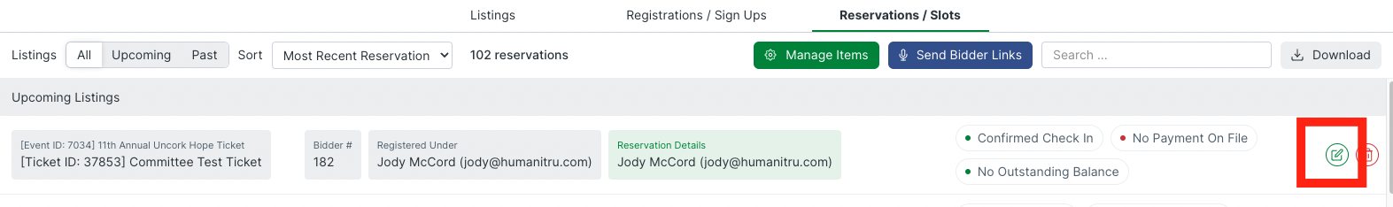**a. If the person is already checked in, skip to step 6.

b. If the ticket holder is not checked in, fill out the following fields:

* 1. Check in name
  2. Email address
  3. Cell phone number

*If you click “Prefill Registration”, it will add the original registrant's name and email address to their guest's ticket. **ONLY use the prefill button when the person who registered for the ticket is the person checking in.**

1. **[THIS STEP IS NOT REQUIRED AND CAN BE REMOVED FROM THIS PROCESS] Ask if they would like to close out via cash, check, or credit card and select that option from the “Preferred Close Out Method” drop down menu.**
2. **[THIS STEP IS NOT REQUIRED AND CAN BE REMOVED FROM THIS PROCESS] Ask if they would like to cover the payment processing fee, which is about [INSERT YOUR PROCESSING RATE]%. Select their answer from the “Opted-In to Cover Processing Fee” drop down.**
3. **Click the green “Save and Check In” button.**
4. **Under “Send Self Check-In Instructions'', click the blue “Send via Text” button.** Advise them that they will receive a text shortly with a link to their bidder profile. It is a good idea to confirm that the guest receives their text.
5. **[THERE ARE 3 WAYS TO COLLECT A TICKET HOLDERS CREDIT CARD INFORMATION. CHOOSE WHICH METHOD YOU WOULD LIKE TO USE BELOW AND DELETE THE OTHERS.]**

**1 - [ADD YOUR SWIPER INSTRUCTIONS]**

**2 -AUCTIONS - Ask guests to fill in their own credit card information by directing them to the link in their text.** This link will take them to their bidder profile. They MUST click this link and complete their bidder profile by adding their credit card before they can bid on any items.

**3 GENERAL EVENTS - Enter guest credit card information for them by clicking the blue “Input Payment to be on File (Credit Card)” button on the left side of the check in screen.** Enter their credit card information into the fields and click the green “Submit Card to be on file”.

* 1. Be VERY careful when inputting credit card information. You only want to use the blue “Transfer Card used from Registration” button when the original registrant is checking in, otherwise you will add their credit card to their guests profiles and they will get charged for all of their guests activities. **If you will notice when adding credit card information manually during check-in that the previous individual's credit card information is carried over to your next guest check-in be sure to manually delete all credit card fields and input the correct guests credit card information.**
  2. Guests will be emailed an itemized receipt at the end of the night for items won, or items purchased

1. **[THIS LANGUAGE MAY NEED TO BE UPDATED DEPENDING ON YOUR PROCESS] Write their bidder number on a bidder paddle and let them know they can use it to purchase items and donate during the live ask throughout the night**

Bidder numbers are located here: 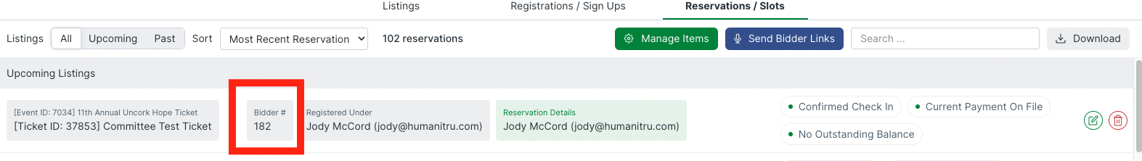

1. **Click the “X” on the left side of the screen to close out the profile and check in the next guest.**

